PHYS 201 Help Session on Equilibrium and Statics 11/14/19,﻿11-12, Sims 209.
1. Before coming, please watch the attached video and be ready to talk about what you learned from the video. ﻿﻿﻿﻿﻿ ﻿﻿﻿﻿﻿﻿﻿﻿﻿﻿﻿﻿﻿﻿﻿﻿﻿https://www.youtube.com/watch?v=0BIgFKVnlBU
2. A gymnast with mass 46.0 kg stands on the end of a uniform balance beam as shown below. The beam is 4.60 m long and has a mass of 260 kg (excluding the mass of the two supports). Each support is 0.500 m from its end of the beam. Assume that the forces on the beam due to support 1 and support 2 are vertical.
a. Draw a free-body diagram for the beam.
b. Write down a force equation by balancing the forces vertically.
c. Write down a torque equation by balancing the torques.
d. Calculate the forces on the beam due to (a) support 1 and (b) support 2?
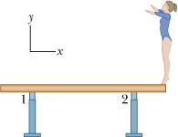

3. The uniform seesaw shown below is balanced on a fulcrum located 3.0 m from the left end. The smaller boy on the right has a mass of 40 kg and the bigger boy on the left has a mass 80 kg.
a. What is the mass of the board? b. What is the normal force by the fulcrum?
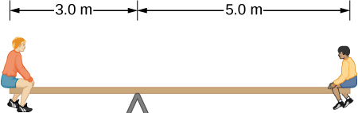

4. A 50-kg person stands 1.5 m away from one end of a uniform 6.0-m-long scaffold of mass 70.0 kg. Find the tensions in the two vertical ropes supporting the scaffold.
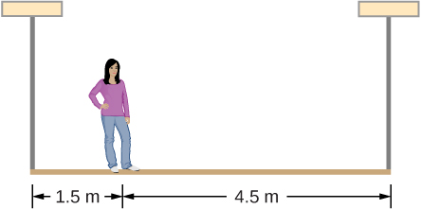

5. A uniform plank of length 5.0 m and weight 225 N rests horizontally on two supports, with 1.1 m of the plank hanging over the right support (see the drawing). To what distance, x can a person who weighs 450 N walk on the overhanging part of the plank before it just begins to tip?
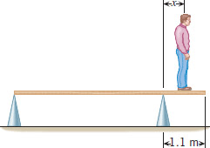

Muscles, bones, and joints are some of the most interesting applications of statics. There are some surprises. Muscles, for example, exert far greater forces than we might think. Figure 9.26 shows a forearm holding a book and a schematic diagram of an analogous lever system.
Muscles can only contract, so they occur in pairs. In the arm, the biceps muscle is a flexor—that is, it closes the limb. The triceps muscle is an extensor that opens the limb. This configuration is typical of skeletal muscles, bones, and joints in humans and other vertebrates. Most skeletal muscles exert much larger forces within the body than the limbs apply to the outside world. The reason is clear once we realize that most muscles are attached to bones via tendons close to joints, causing these systems to have mechanical advantages much less than one. Viewing them as simple machines, the input force is much greater than the output force, as seen in Figure 9.26.
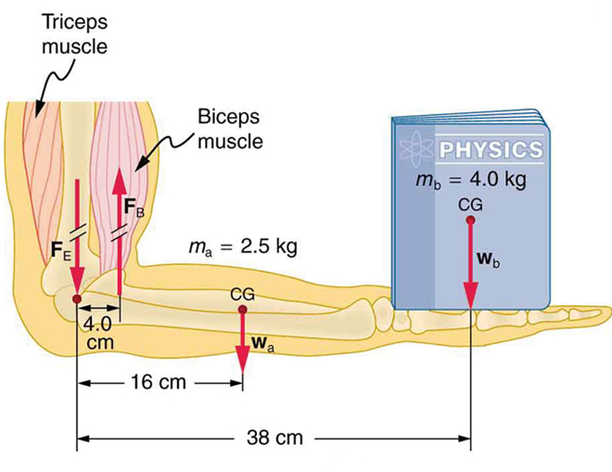

VI. A 800-N uniform horizontal beam of length 12.0 m is hinged to a vertical wall at one end and is supported by a cable at the other end as shown below. Assume θ = 30⁰.
1. Draw a free-body diagram for the beam, showing all the forces acting on the beam, including the horizontal (R_{x}) and vertical (R_{y}) forces exerted by the wall on the beam.
2. Break the tension in the cable into horizontal and vertical components.
3. Write down two equations by balancing the forces in x and y directions.
4. Write down the torque equation.
5. Find the tension in the cable and the horizontal and vertical forces exerted by the wall on the beam.
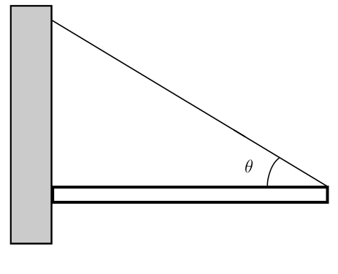

VII. A 1200-N uniform horizontal beam of length 8.0 m is hinged to a vertical wall at one end and is supported by a cable at the other end as shown below. A fireman of mass 65-kg is standing on the beam at 5.0 m from the hinge.
1. Draw a free-body diagram for the beam, showing all the forces acting on the beam, including the horizontal (R_{x}) and vertical (R_{y}) forces exerted by the hinge on the beam.
2. Break the tension in the cable into horizontal and vertical components.
3. Write down two equations by balancing the forces in x and y directions.
4. Write down the torque equation.
5. Find the tension in the cable and the horizontal and vertical forces exerted by the hinge on the beam.

